Task 3 BlockChain

Assignment 1

1. Used Remix IDE.
2. It is browser based smart contract framework.
3. No installation required.
4. Created a .sol file named “MyFirstContact”.

This Solidity code defines a simple smart contract named simpleContract. It has two private variables: age (an unsigned integer) and name (a string). The contract includes four functions:

* **Setter Functions**:
  + setName: Sets the name variable.
  + setAge: Sets the age variable.
* **Getter Functions**:
  + getName: Returns the current name.
  + getAge: Returns the current age.

These functions allow users to modify and retrieve the contract's state. The view keyword in getter functions indicates that they do not modify the state of the contract.

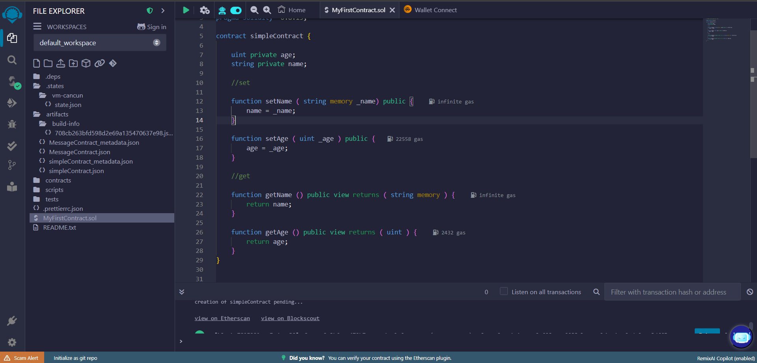

1. Manual compilation done (Auto Compile was not enabled)

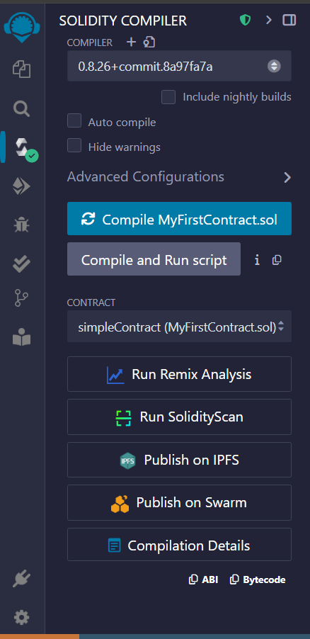

1. Deployed the contract using the Remix VM (Cancun) as the Environment. Reference : <https://youtu.be/kfKpXHy3pPg?si=FuvVqE4MQwuczsd->
2. After successful deployment, tried the setAge ,setName, getAge and getName functions.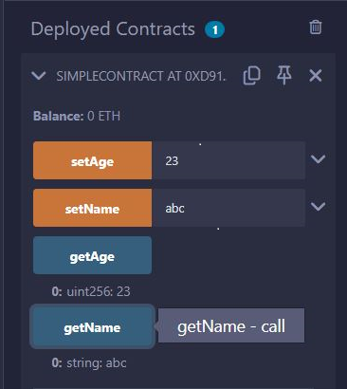
3. Installed the MetaMask extension from ChromeStore.
4. Visited for faucet : <https://cloud.google.com/application/web3/faucet/ethereum/sepolia> to get SepoliaETH tokens (got help from a friend). Tried to make an Alchemy account and get the tokens, but failed since there is a minimum cap on ETH tokens one must initially have to avoid spammers.

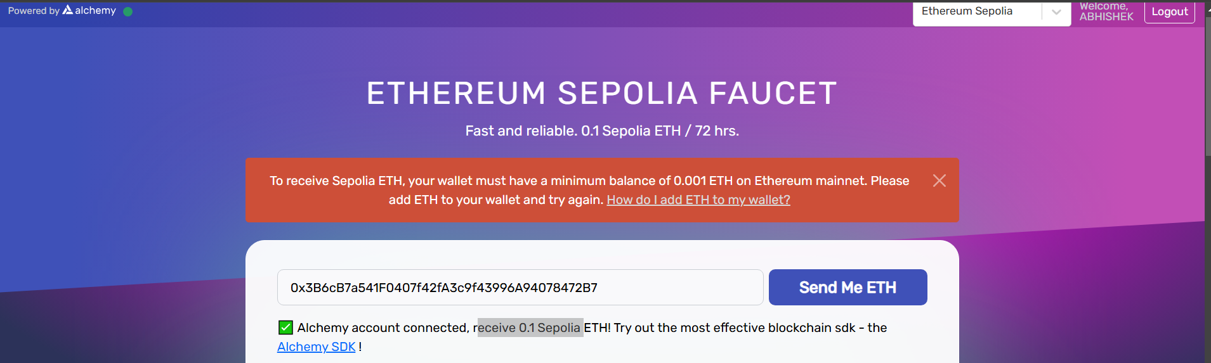

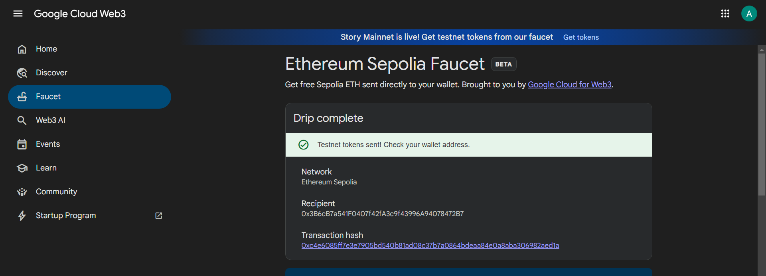

1. Now deployed the smart contact on sepolia testnet by first going to <https://chainid.network/> and searching “sepolia”.

Cl

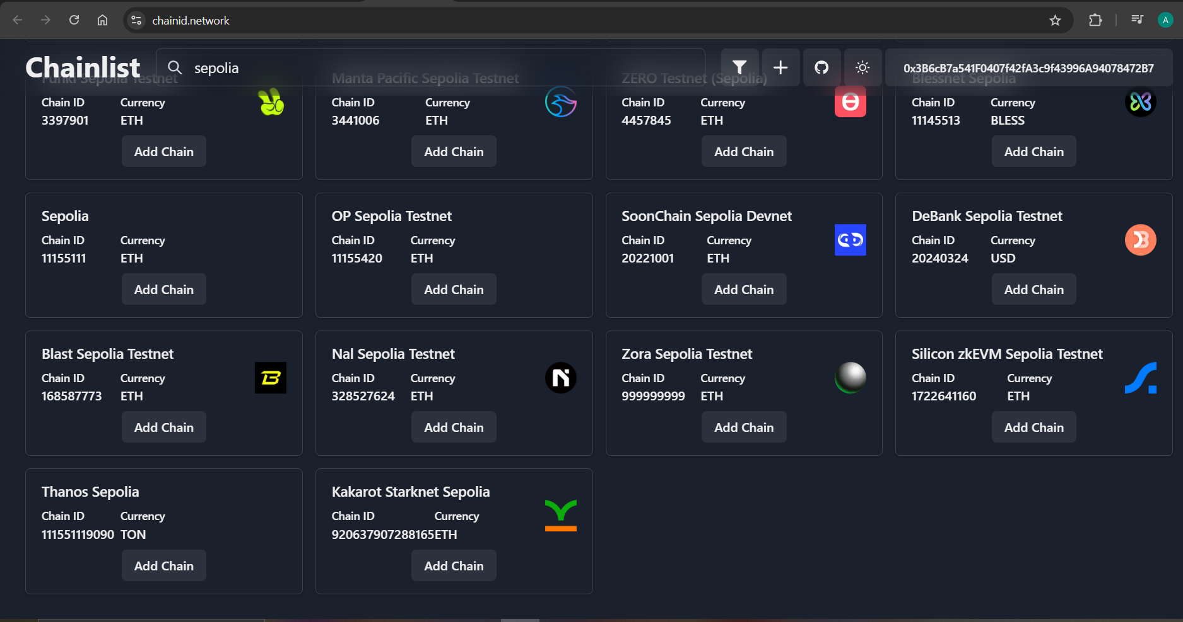

Click on “Add Chain” and you get a prompt from MetaMask ,accept it.

1. Go to Remix Ide, select the environment WalletConnect,choose MetaMask. The video reference : <https://youtu.be/I_OZd0HN7ro?si=eaeXK54MBBjdHWox>. It mentions to select “Injected Provider -MetaMask”, but it was not there.
2. Some ETH around 0.0005 was charged(deducted) for deployment and for setAge it was around 0.0001. It took longer for deployment than previous case. 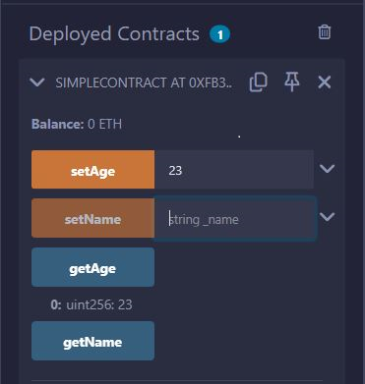
3. 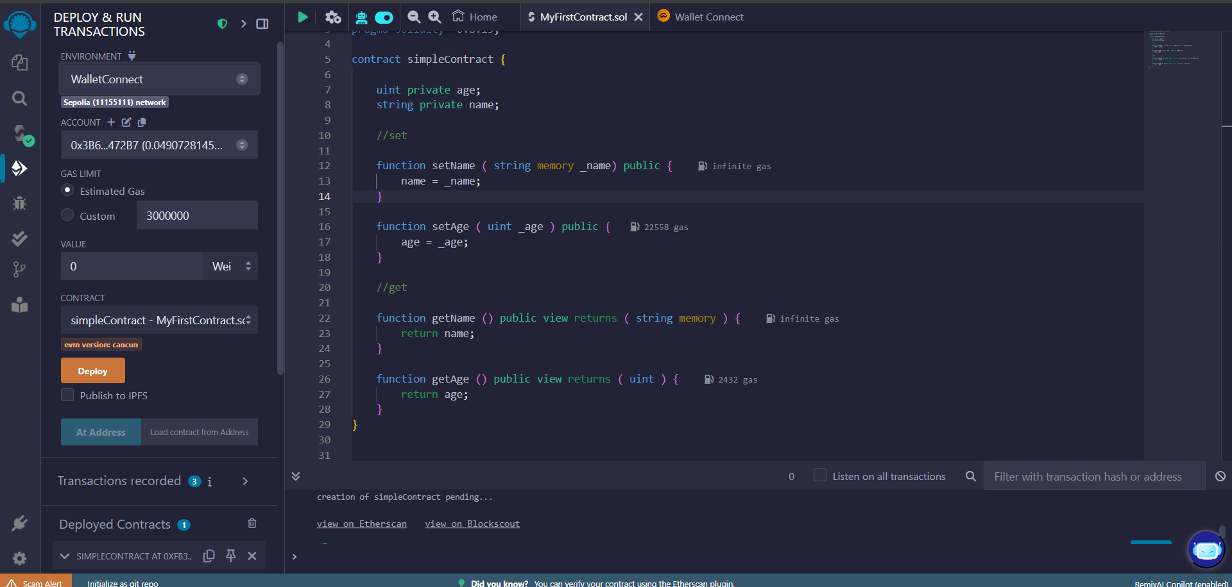Clicked on “View on Etherscan”

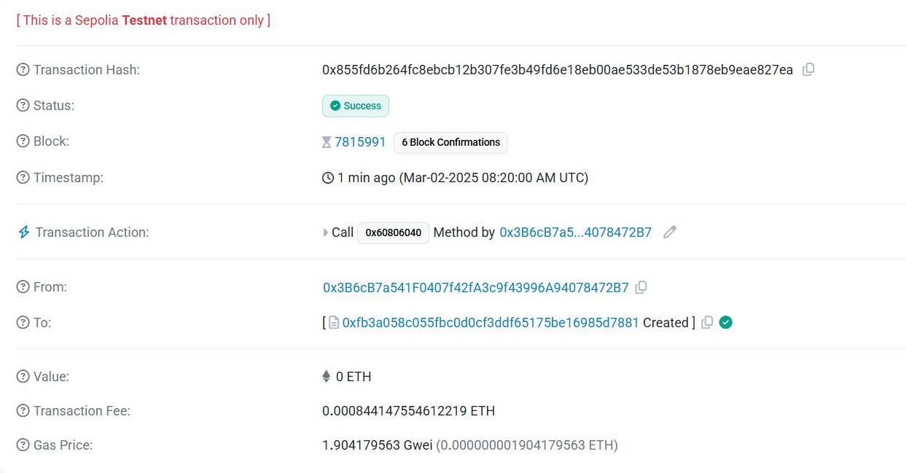

Obtained information about the transaction.

Github : <https://github.com/Ccode104/Blockchain>

Assignment 2

1. Minting means to add tokens, Burning means to remove tokens, while transfer just changes the ownership of the tokens.
2. We can create our own token with a custom name and abbreviation as well.
3. 3 functions : mint,burn and transfer is defined. Total_Supply variable tracks the total number of tokens.

Check the token name,abbreviation and total supply.

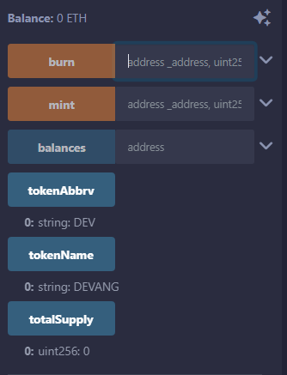

Assignment 3

https://github.com/andresudi/Voting-Smart-Contract

Mint 100 tokens to your address(or any other address)

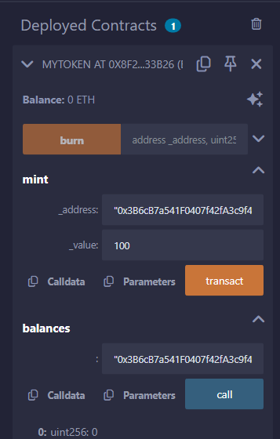

Check the balance. You will see 100 tokens in your account as the balance.

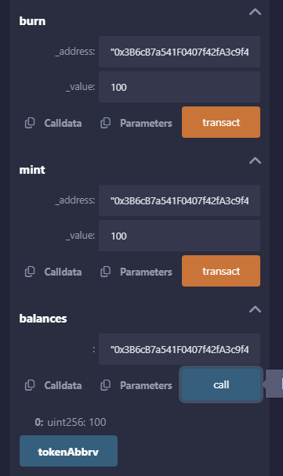

Burn 100 tokens (We had just minted 100 tokens) and you see the balance 0

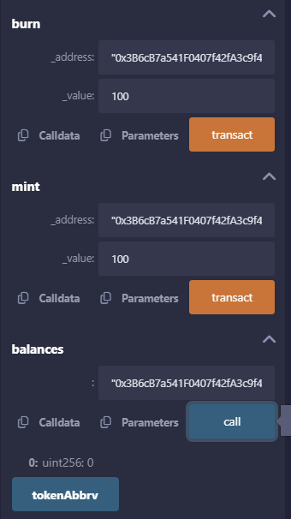

View the transaction details on Etherscan

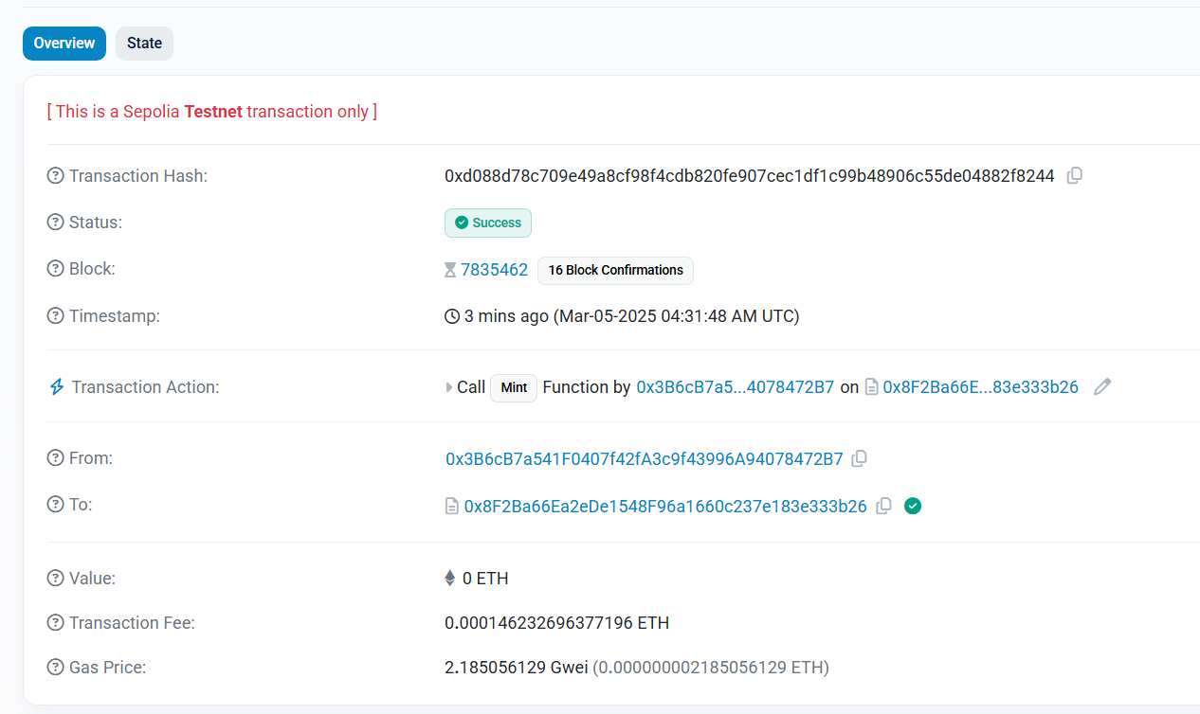

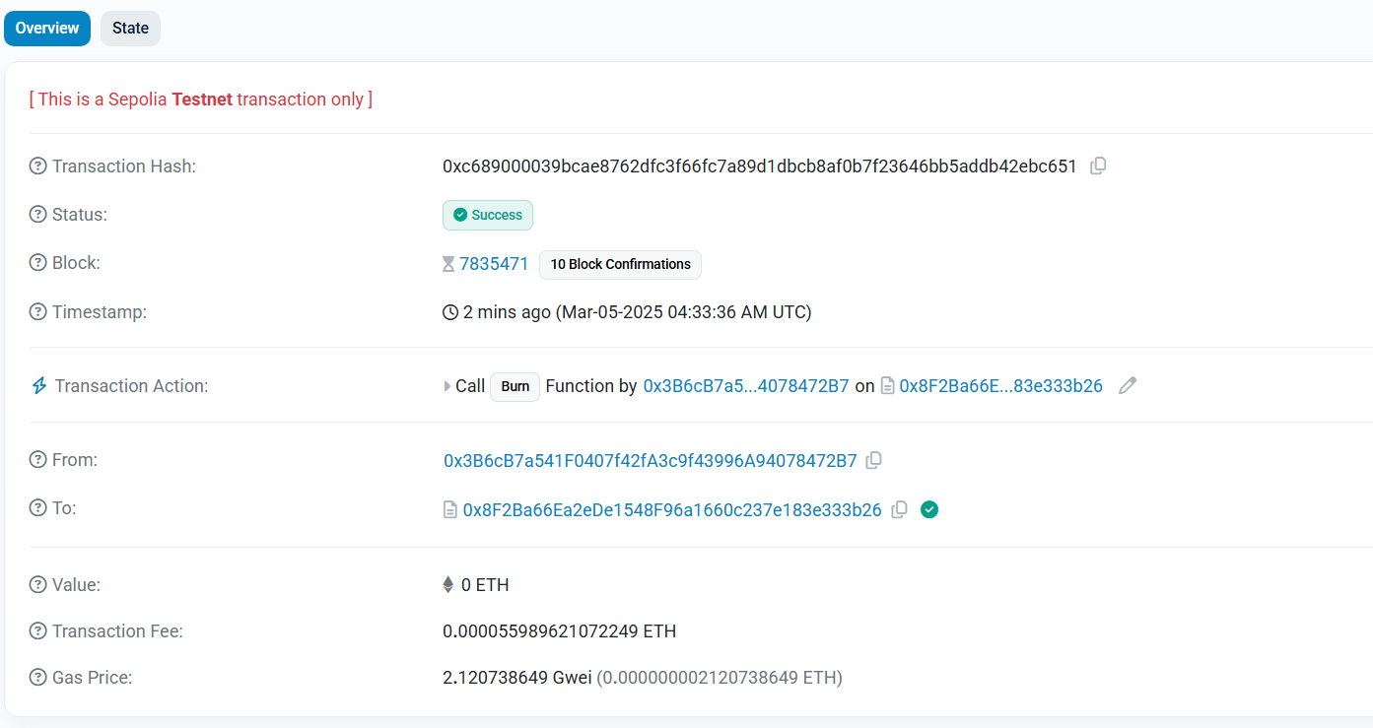

References : <https://github.com/Dev902/-ERC20-Token-Contract-with-Mint-and-Burn-Functions--/tree/main>

Assignment 4

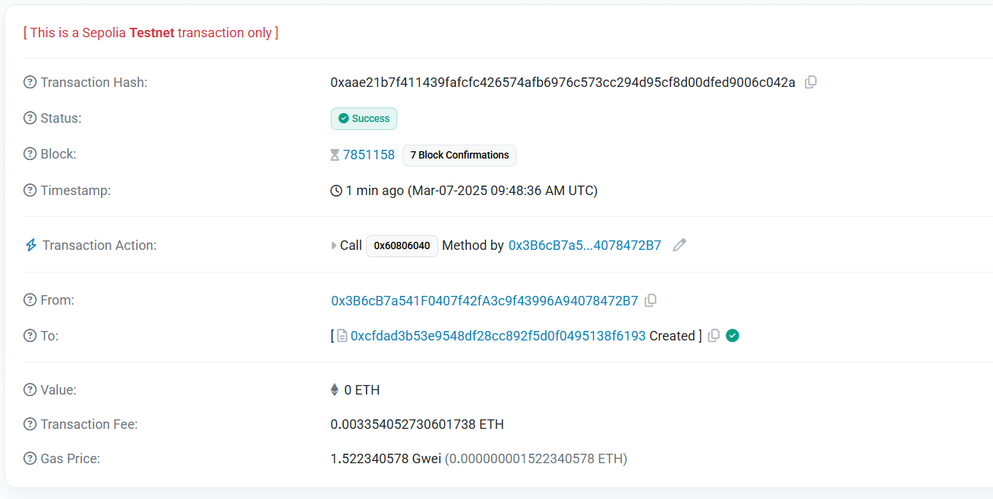ERC721 Smart Contarct Deployed

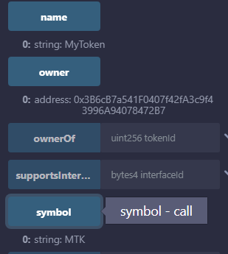Name Owner Symbol

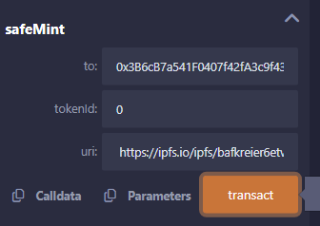Mint the token to yourself

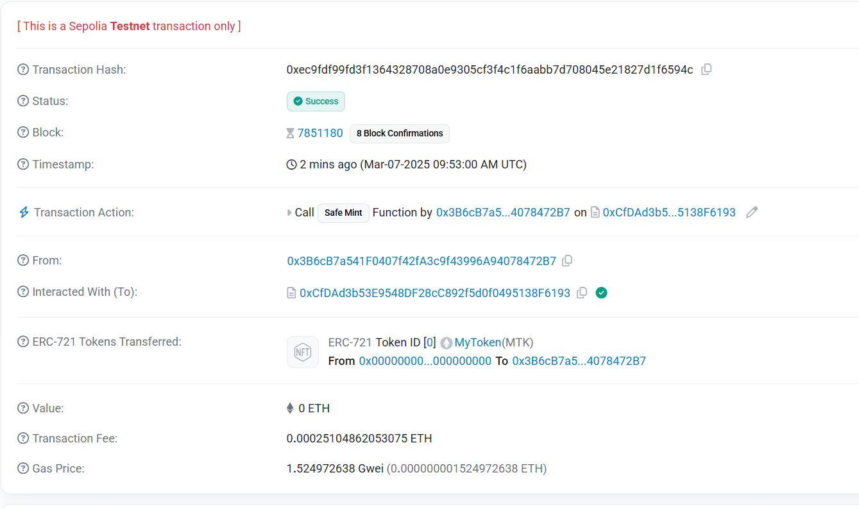Mint Success!

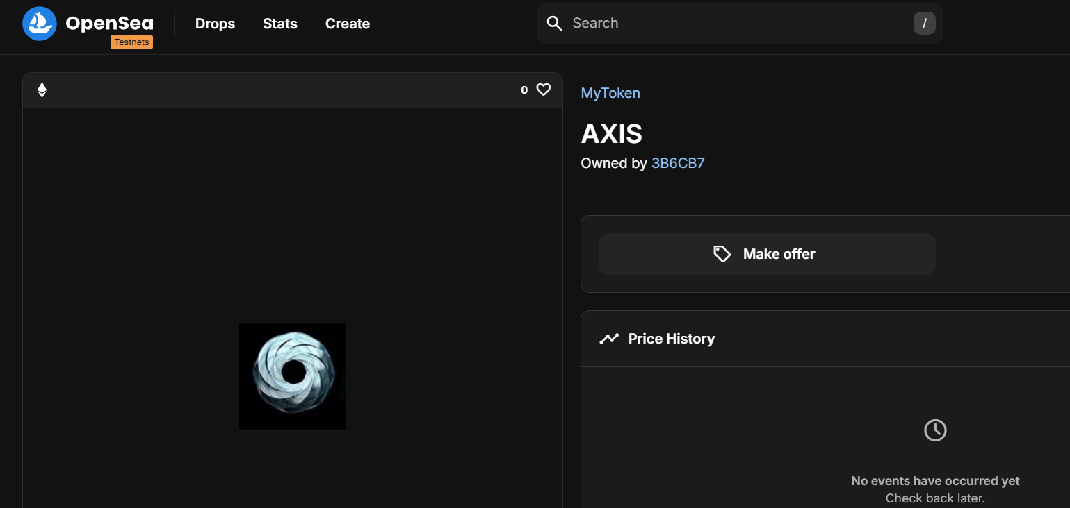Check on opensea testnets by using contract address

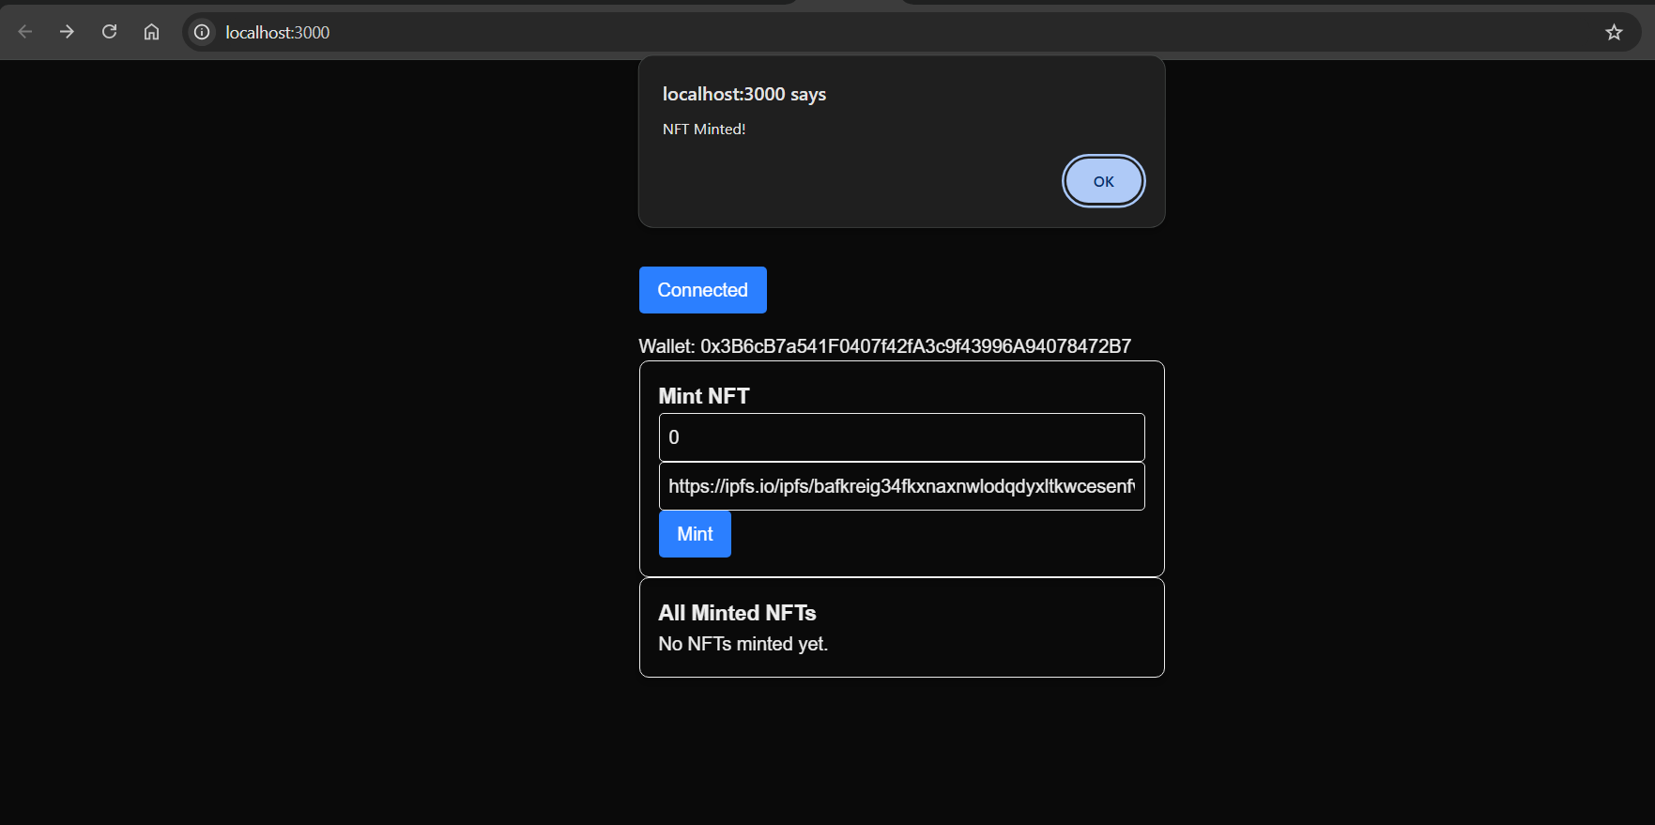

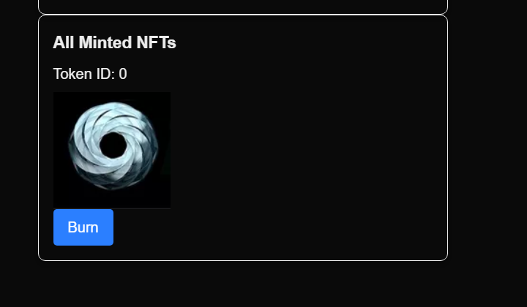

Pre-requisites(Linux) : https://hyperledger-fabric.readthedocs.io/en/latest/prereqs.html

Fabric and Fabric Samples : <https://hyperledger-fabric.readthedocs.io/en/latest/install.html>

Using fabric net : <https://hyperledger-fabric.readthedocs.io/en/latest/test_network.html>

Deploy : <https://hyperledger-fabric.readthedocs.io/en/latest/deploy_chaincode.html>

Custom Chaincode Guide : <https://hyperledger-fabric.readthedocs.io/en/latest/chaincode4ade.html>

sudo apt-get install git curl docker-compose -y

*# Make sure the Docker daemon is running.*

sudo systemctl start docker

*# Add your user to the Docker group.*

sudo usermod -a -G docker <username>

*# Check version numbers*

docker --version

docker-compose --version

*# Optional: If you want the Docker daemon to start when the system starts, use the following:*

sudo systemctl enable docker

Help (To install GO) : <https://dev.to/karleeov/wsl-install-go-27ji>

Running Network using docker compose – shows the containers



Query an initialized chaincode asset (See the initialization in contract)



Read an asset



Read all assets



Add an asset



For custom chaincode do this in the folder where you stored the chaincode:

go mod init mychaincode

go mod tidy ,go mod vendor

Store asset



Retrieve Asset



Iot sensor – Belong to org1 (Write)

Authorized users – Belong to org2 (Read)

